BSCS FINAL PROJECT
Software Design Specification

SkillsVerse



Project Advisor

Prof. Fahad Shahzad

Presented by:
Group ID: F22BSCS002

Student Reg# Student Name

Faculty of Information Technology & Computer Science

University of Central Punjab
Software Design Specification
SDP Phase II

SkillsVerse
Advisor: Prof. Fahad Shahzad

Team 02
Member Name | Primary Responsibility
Saqib Ali | Chapters 1
Naeem Ullah Shahab | Chapter 2,3,4

Table of Contents
Table of Contents i
Revision History ii
Previous Phases Feedback ii
Abstract iii
1. Introduction 1
1.1 Product 1
1.2 Background 1
1.3 Objective(s)/Aim(s)/Target(s) 2
1.4 Scope 3
1.5 Business Goals 3
1.6 Document Conventions 4
1.7 Miscellaneous 4
2. Overall Description 5
2.1 Product Features 5
2.2 Functional Description 5
2.3 User Classes and Characteristics 6
2.4 Design and Implementation Constraints 7
2.5 Assumptions and Dependencies 7
3. Specific Requirements 3
3.1 External Interface Requirements 5
3.1.1 System Interfaces 5
3.1.2 Interfaces 5
3.1.3 Hardware Interfaces 5
3.1.4 Software Interfaces 6
3.1.5 Communications Interfaces 6
3.2 Functional Requirements 6
3.2.1 New Construction Service Module 6
3.2.2 Daily Routine Service Module 7
3.3 Use Cases 7
3.3.1 Customer Use Case Diagram 7
3.3.1.1 Customer Daily Routine Use Case Diagram 7
3.3.1.2 Customer Newly Constructed Use Case Diagram 7
3.3.2 Worker Use Case Diagram………………………………………. 7
3.3.2.1 Worker Daily Routine Use Case Diagram………………………………….. 7
3.3.2.2 Worker Newly Construction Use Case Diagram…………………………………. 7
3.3.3 Admin Use Case Diagram 7
3.3.1.1 Admin Daily Routine Use Case Diagram 7
3.3.1.2 Admin Newly Constructed Use Case Diagram 7
3.3.4 SkillsVerse Use Case Diagram 7

3.4 Classes / Objects 7
SkillsVerse Class Diagram
3.5 Non-Functional Requirements 7
3.5.1 Performance 8
3.5.2 Reliability 8
3.5.3 Availability 8
3.5.4 Security 8
3.5.5 Maintainability 8
3.5.6 Portability 8
3.6 Inverse Requirements 8

4. Screenshots/Prototype 5
4.1 Workflow 5
4.2 Screens 5
4.3 Additional Information 5
5. Other Design Details 5
6. Revised Project Plan 5
7. References 5
Appendix A: Glossary 6
Appendix B: IV & V Report 7

Revision History
Name | Date | Reason For Changes | Version

Previous Phases Feedback

Idea Defence Feedback (Screenshot)

Abstract
SkillsVerse is a web-based service marketplace developed as a Final Year Project (FYP) to address the challenge of finding reliable and verified skilled workers in local communities. Traditional hiring methods rely on personal references and manual searches, which are often inefficient, time-consuming, and unstructured. SkillsVerse provides a centralized digital platform that connects customers with skilled workers in a secure and organized manner.
The platform offers two major service modules: New Construction Services and Daily Routine Services. In the New Construction module, customers submit project details that are reviewed and managed by the administrator before being assigned to a suitable worker. In the Daily Routine module, customers can select a specific service (such as electrician, plumber, carpenter, cleaning, or painting), record their problem using a voice recording feature, and send a request. The system automatically forwards the request to the nearest available approved worker in real-time.
Workers can register, create detailed professional profiles, and become active members of the platform after admin approval. Once approved, workers can manage their availability status to receive real-time job requests. An integrated admin panel ensures transparency by verifying worker profiles, approving applications, monitoring activities, and managing service requests.
SkillsVerse follows a commission-based earning model, where the platform deducts a small percentage from each completed transaction. The system is developed using the MERN stack (MongoDB, Express.js, React.js, and Node.js) and follows a client-server architecture to ensure scalability and maintainability.
The primary goal of SkillsVerse is to simplify the hiring process, improve service reliability, create better employment opportunities for skilled workers, and provide a structured digital solution for local service needs. The system also provides a scalable foundation for future enhancements such as mobile application development, digital wallet integration, and AI-based recommendations.

Introduction

Product
SkillsVerse is a web-based service marketplace platform designed to connect customers with verified skilled workers in their local areas. The system provides a structured and secure environment where users can request services, communicate their problems, and complete transactions efficiently.
The product consists of three main user roles: Customer, Worker, and Admin.
Customers can access two major service modules: New Construction Services and Daily Routine Services. In the New Construction module, customers submit project details that are reviewed and managed by the administrator before being assigned to a suitable worker. In the Daily Routine module, customers select a specific service category, describe their issue using a voice recording feature, and send a request. The system automatically forwards the request to the nearest available approved worker in real-time.
Workers can register on the platform, create professional profiles, and upload required verification information. After admin approval, workers become active members of the platform and can manage their availability status. When marked as available, workers receive real-time service requests and can accept or decline them.
The Admin is responsible for verifying worker registrations, approving or rejecting applications, managing service requests, and monitoring transactions. The system operates on a commission-based earning model, where a percentage of each completed transaction is retained by the platform.
SkillsVerse is developed using the MERN stack (MongoDB, Express.js, React.js, and Node.js) and follows a client-server architecture to ensure scalability, security, and maintainability.

1.2 Background
Previously, hiring skilled workers such as electricians, plumbers, carpenters, cleaners, and painters was mainly done through word-of-mouth, personal references, or local market visits. These traditional methods are often unreliable, time-consuming, and lack proper verification. Customers usually face difficulties in finding trusted workers quickly, while workers struggle to get consistent job opportunities.
Although some online platforms exist, many of them:
- Focus more on freelancing and remote digital services rather than local skilled services.
- Lack proper worker verification and structured admin approval mechanisms.
- Do not provide efficient location-based request matching.
- Do not ensure real-time service request delivery to available workers.
SkillsVerse addresses these limitations by introducing a structured and verified service marketplace tailored specifically for local skilled services.
SkillsVerse differentiates itself by:
- Providing two structured service modules: New Construction Services and Daily Routine Services.
- Offering category-based verified worker profiles.
- Implementing an admin approval mechanism to verify worker registrations before activation.
- Introducing a structured hire request system with voice-based problem description.
- Ensuring real-time request delivery to the nearest available approved workers.
- Allowing customers to submit reviews and ratings after service completion.
- Using a commission-based earning model to maintain a sustainable and transparent platform.
By combining verification, real-time request handling, and location-based worker matching, SkillsVerse provides a more reliable, secure, and efficient solution for hiring skilled workers in local communities.

Objective(s)/Aim(s)/Target(s)
The objectives of the SkillsVerse project are:
- To design and develop a centralized web-based platform that connects customers with verified skilled workers in local communities.
- To provide two structured service modules: New Construction Services (admin-managed workflow) and Daily Routine Services (real-time automated workflow).
- To ensure worker verification through profile registration, document submission, and admin approval before activation.
- To simplify the hiring process through a structured online service request system with voice-based problem description.
- To implement real-time request delivery to the nearest available and approved workers only.
- To allow workers to manage their availability status in order to receive real-time service requests.
- To introduce a commission-based earning model that automatically calculates platform earnings from completed transactions.
- To enable customers to submit authentic reviews and ratings after service completion to maintain transparency and trust.
- To develop a scalable, secure, and maintainable web application using the MERN stack (MongoDB, Express.js, React.js, and Node.js) within the FYP timeline.

Scope
The scope of the SkillsVerse project encompasses the development of a web-based service marketplace application that facilitates efficient and reliable hiring of skilled workers. The system includes the following functionalities:
- Customer and worker registration with secure authentication.
- Worker profile creation, detailed information upload, and verification through admin approval.
- Two structured service modules: New Construction Services (admin-managed workflow) and Daily Routine Services (real-time automated workflow).
- Category-based worker listings for easy selection of services such as electrician, plumber, carpenter, cleaning, and painting.
- Location-based hire request management, ensuring requests are sent only to nearby available and approved workers.
- Voice-based problem description for customers to clearly communicate service requirements.
- Real-time notifications to online and available workers for immediate request handling.
- Allowing fair service pricing between customer and worker.
- Commission-based platform earnings calculated automatically from completed transactions.
- Rating and review system where customers can provide feedback after service completion.
- Admin panel for worker verification, request monitoring, approval/rejection of applications, and overall activity tracking.
The current version of the system is designed for web browsers, providing a scalable foundation for future enhancements such as mobile applications, AI-based service recommendations, integrated online payment gateways, and digital wallet support.

Business Goals
The business goals addressed by SkillsVerse are:
- To create a trustworthy and structured digital marketplace specifically for local skilled services, connecting verified workers with customers efficiently.
- To reduce inefficiencies and uncertainties inherent in traditional hiring methods such as word-of-mouth, personal references, and local visits.
- To increase visibility and provide consistent job opportunities for skilled workers by enabling them to manage verified profiles and receive real-time service requests.
- To enhance customer satisfaction and trust by providing verified worker profiles, voice-based problem submission, real-time service requests, and a rating/review system.
- To support future commercialization and scalability, including potential mobile applications, AI-based service recommendations, online payment integration, and expanded service categories.

Document Conventions
The following conventions are used in this SRS document:
- All section headings are numbered for clarity and reference.
- Important terms are written in bold when first introduced.
- Functional requirements use the term "shall" to indicate mandatory behavior.
- Technical terminology follows standard software engineering conventions.
- The document uses formal English suitable for academic and professional review.

Miscellaneous
This document is prepared to guide the design, development, and evaluation of the SkillsVerse project. It serves as a reference throughout the project lifecycle. Any enhancements, such as mobile application support and AI-based recommendations, are considered future work and are not part of the current implementation

2. Overall Description

2.1 Product Features
SkillsVerse offers a comprehensive platform for connecting customers with verified local skilled workers. The key features of the system include:
- Two Service Modules:
  - New Construction Services: Admin-managed workflow for large-scale projects.
  - Daily Routine Services: Real-time automated workflow with nearest available worker assignment.
- Worker Registration and Verification: Workers can create detailed profiles, upload verification documents, and await admin approval before becoming active.
- Voice-Based Problem Submission: Customers can describe their service issues using a voice recording feature for clearer communication.
- Real-Time Request Management: Requests are automatically routed to the nearest available approved workers, ensuring timely service delivery.
- Commission-Based Payment System: The platform deducts a fixed percentage from each completed transaction, ensuring sustainable earnings.
- Rating and Review System: Customers can provide feedback after service completion, enhancing transparency and trust.
- Admin Panel: Admin can verify workers, approve or reject applications, monitor requests, and track overall system activity.
- Scalability and Future Enhancements: Designed to support future features like mobile apps, AI-based service recommendations, and integrated online payment gateways.

2.2 Functional Description
The system provides the following functional capabilities:
- Customer Functions:
  - Browse and select service modules.
  - Submit hire requests with detailed descriptions or voice recordings.
  - Track service requests in real-time.
  - Submit ratings and reviews after service completion.

- Worker Functions:
  - Register and create professional profiles.
  - Manage availability status to receive real-time requests.
  - Accept or decline service requests.
- Admin Functions:
  - Approve or reject worker registrations.
  - Monitor service requests and real-time system activity.
  - Track platform earnings and transaction history.
- System Functions:
  - Match customer requests with the nearest available approved workers.
  - Securely process commission-based payments.
  - Log all interactions for audit and monitoring purposes.

2.3 User Classes and Characteristics
The system caters to three primary user classes:
- Customer:
  - Seeks local skilled services.
  - Can submit requests, track services, and provide ratings/reviews.
  - Requires easy navigation and clear communication tools (voice/text).
- Worker:
  - Provides skilled services.
  - Registers, creates profiles, and manages availability.
  - Needs real-time notifications and clear request acceptance flow.
- Admin:
  - Monitors and manages the platform.
  - Approves worker registrations, oversees transactions, and ensures system integrity.
  - Requires a comprehensive dashboard with analytics and reporting tools.

2.4 Design and Implementation Constraints
The SkillsVerse system is subject to the following constraints:
1. Technological Constraints:
- The web application shall be developed using the MERN stack (MongoDB, Express.js, React.js, Node.js).
- The application shall be hosted on standard web browsers; mobile application support is considered future work.
2. Operational Constraints:
- Service requests shall only be sent to online and available workers.
- A minimum base price shall be enforced to ensure fair negotiation between customers and workers.
3. Security Constraints:
- Worker verification shall require admin approval before activation.
- Sensitive user data, including personal details and payment information, shall be stored securely following best practices.
4. Design Standards:
- The system shall follow a client-server architecture to ensure scalability and maintainability.
- All code shall be written in JavaScript / Node.js, adhering to standard coding conventions and best practices.

2.5 Assumptions and Dependencies
- Assumptions:
  - Workers will update online/offline status accurately.
  - Customers provide the correct location for request matching.
  - Admin will regularly monitor and approve/reject worker profiles.
- Dependencies:
  - Map API (Google Maps or similar) for location-based requests.
  - Web server to host the MERN stack application.
  - Internet connectivity for real-time request notifications.
  - Future third-party payment gateways if integrated.

3. Specific Requirements

3.1 External Interface Requirements
The SkillsVerse system interacts with several external interfaces to ensure smooth operation, real-time request handling, and secure transactions.

3.1.1 System Interfaces
- Map Services API (e.g., Google Maps) for location-based nearest worker matching.
- Payment Gateway APIs (future integration) for secure online transactions.
- Web Server Interface to host the MERN stack application and manage HTTP requests/responses.
- Notification Services for real-time updates to customers and workers.

3.1.2 User Interfaces
- Customer Web Interface: Accessible via web browsers; allows request submission, voice recording, tracking, and review submission.
- Worker Web Interface: Profile management, availability toggle, request acceptance, and job tracking.
- Admin Dashboard: Worker verification, request monitoring, transaction tracking, and analytics.

3.1.3 Hardware Interfaces
- Customer and Worker devices: Desktop or mobile devices with microphone support for voice-based problem submission.
- Server hardware hosting the MERN stack application.

3.1.4 Software Interfaces
- Frontend: React.js for dynamic user interface.
- Backend: Node.js and Express.js for API handling and business logic.
- Database: MongoDB for storing user, worker, request, and payment data.
- Third-party libraries for notifications, voice recording, and security.

3.1.5 Communications Interfaces
- Internet Connectivity: Required for real-time request notifications and system updates.
- HTTPS Protocol: For secure communication between client, server, and external services.
- WebSocket or similar protocols for real-time request delivery to available workers.

3.2 Functional Requirements
The SkillsVerse system provides the following core functional capabilities, divided by modules and user roles:

3.2.1 New Construction Service Module
- Description: Customers can submit requests for large-scale construction projects. These requests are managed by the admin who assigns a verified worker.
- Inputs: Project details submitted via web form.
- Processing:
  - Admin receives new project request.
  - Admin reviews and assigns a verified worker.
  - Customer is notified of worker assignment.
- Outputs: Worker assignment notification, project tracking updates to the customer.
- Preconditions: Customer must be registered and logged in.
- Postconditions: Request is logged and tracked; commission-based payment recorded upon completion.

3.2.2 Daily Routine Service Module
- Description: Customers can request routine services (electrician, plumber, carpenter, cleaning, painting) with real-time assignment to the nearest available worker. Login is optional for submitting a request.
- Inputs: Service selection, voice recording of problem, customer location.
- Processing:
  - System identifies nearest available verified worker.
  - Worker receives real-time notification of request.
  - Worker accepts or declines the request.
  - Upon service completion, the customer can optionally provide a review and rating (requires login).
- Outputs: Service completion notification, optional customer review submission, commission-based payment calculation.
- Preconditions: Worker must be online and available.
- Postconditions: Worker and customer receive transaction summary; platform commission recorded.

3.3 Use Case Model

3.3.1 Customer Use Case Diagrams

3.3.1.1 Customer Daily Routine Use Case Diagram
Field | Description
Use Case Name | Submit Daily Routine Request
Actor | Customer
Description | Customer selects Daily Routine service and submits request with voice note.
Precondition | Customer must be registered and logged in.
Main Flow | 1. Customer opens Home Page. 2. Clicks "Daily Routine" card. 3. Selects category. 4. Records voice note. 5. Submits request.
Post Condition | Request is created and visible to workers.
Payment Flow | Worker gives price → Customer pays online → Website holds payment → After service 5% commission deducted → Remaining paid to worker.

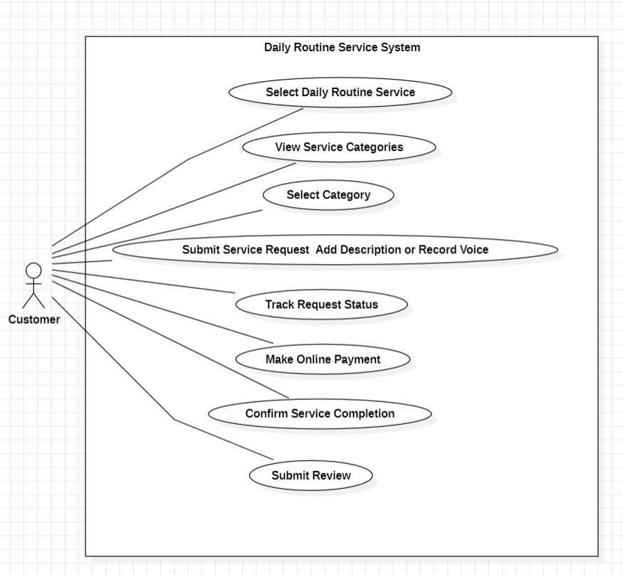

3.3.1.2 Customer Newly Constructed Service Use Case Diagram
Field | Description
Use Case Name | Submit Newly Construction Request
Actor | Customer
Description | Customer submits construction request based on per square feet rate.
Precondition | Customer logged in.
Main Flow | 1. Click "Newly Construction" card.  2. Enter project details (area, location).  3. Worker visits and gives total cost.  4. Customer approves.
Payment Flow | 25% at first visit  50% at half completion  25% after completion
Post Condition | Project marked completed and payment released.

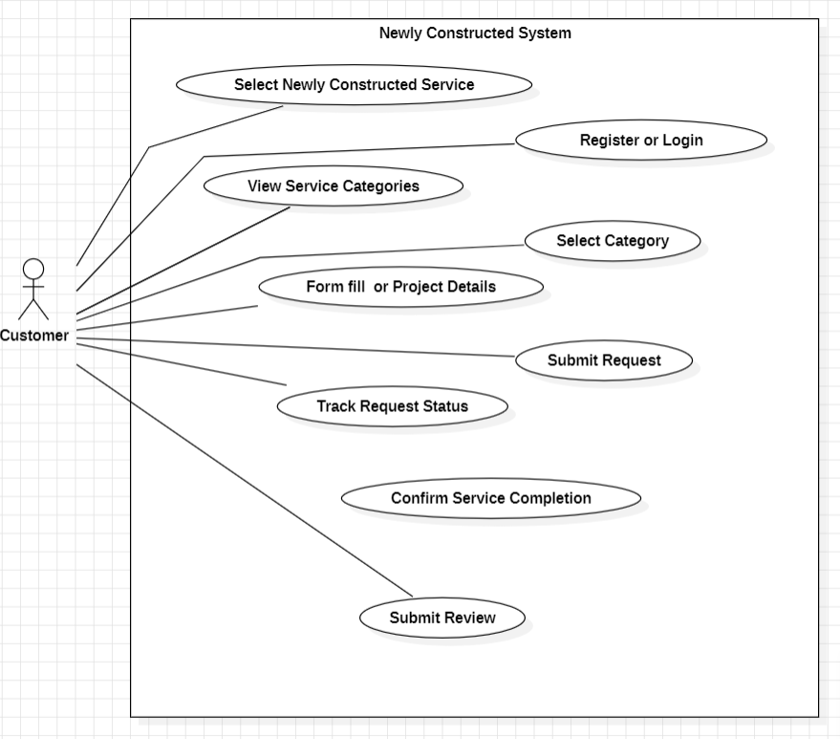

3.3.2 Worker Use Case Diagrams

3.3.2.1 Worker Daily Routine Use Case Diagram
Field | Description
Use Case Name | Accept Daily Request
Actor | Worker
Description | Worker views request and offers price.
Precondition | Worker must be verified by Admin.
Main Flow | 1. Worker logs in. 2. Views Daily requests. 3. Enters price. 4. Waits for customer approval.
Post Condition | Request status updated to "Accepted".

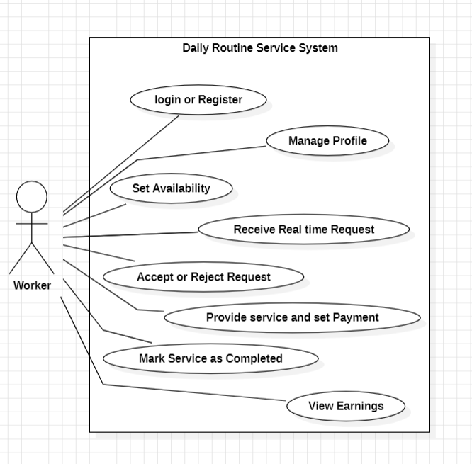

3.3.2.2 Worker New Construction Use Case Diagram

Field | Description
Use Case Name | Manage Construction Project
Actor | Worker
Description | Worker handles project in phases.
Precondition | Project assigned by Admin.
Main Flow | 1. Visit site. 2. Provide total cost (per sq ft). 3. Receive 25% advance. 4. Update progress at 50%. 5. Complete project.
Post Condition | Project completed and full payment processed.

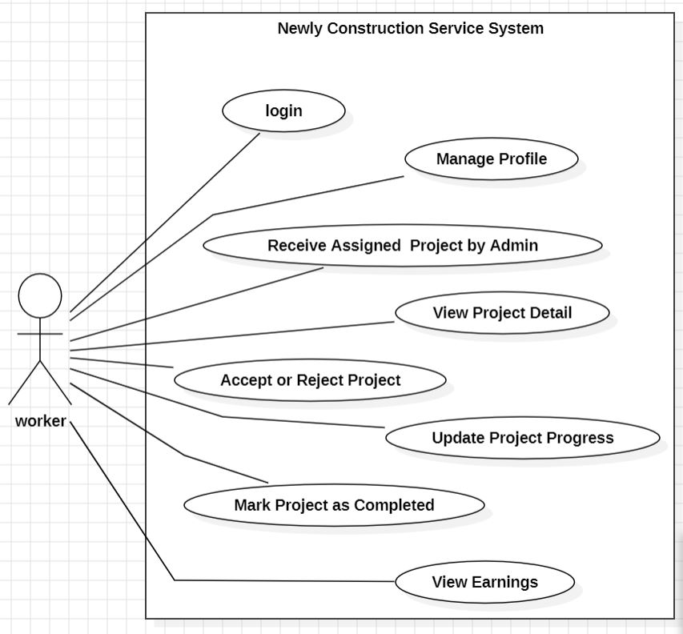

3.3.3 Admin Use Case Diagrams

3.3.3.1 Admin Daily Operations Use Case Diagram
Field | Description
Use Case Name | Verify Worker
Actor | Admin
Description | Admin approves or rejects worker registration.
Precondition | Worker registered.
Main Flow | 1. Admin views pending workers. 2. Checks documents. 3. Approves or rejects.
Post Condition | Worker status updated.

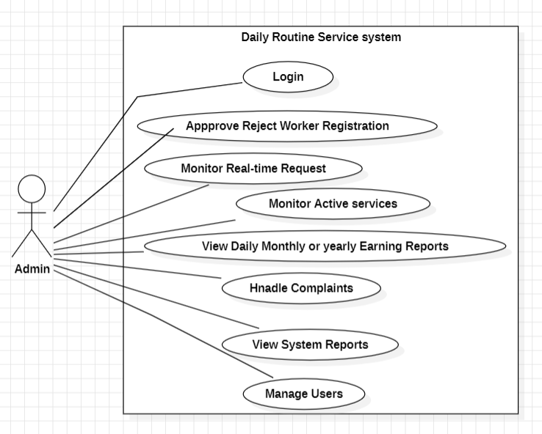

3.3.3.2 Admin Newly Constructed Use Case Diagram
Field | Description
Use Case Name | Manage Payment
Actor | Admin
Description | System deducts 5% commission and releases payment.
Precondition | Service marked completed.
Main Flow | 1. System calculates commission. 2. Deduct 5%. 3. Release remaining amount to worker.
Post Condition | Payment marked successful.

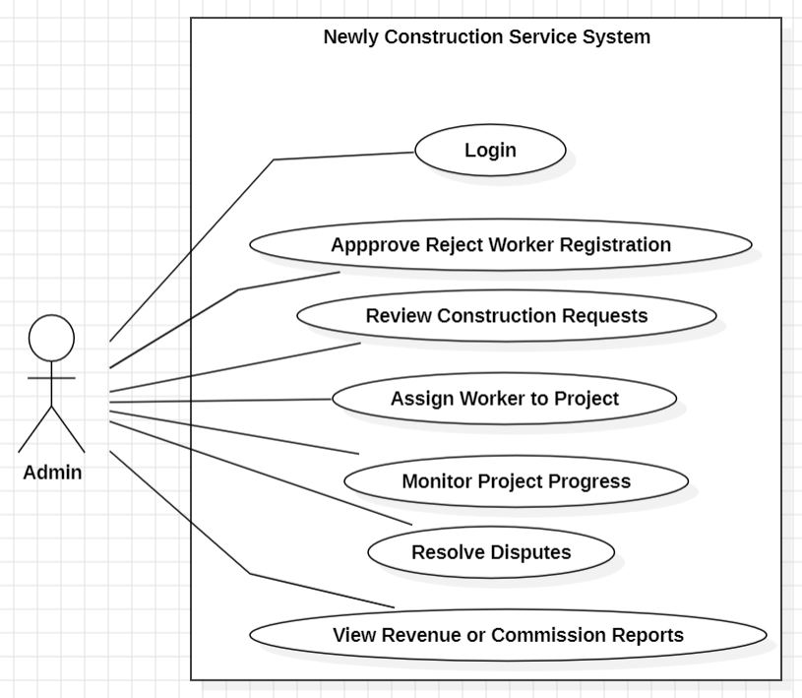

3.3.4 SkillsVerse Use Case Diagram
Field | Description
Use Case ID | UC-01
Use Case Name | Manage Service Request and Payment
Primary Actors | Customer, Worker, Admin
Description | This use case describes the complete workflow of submitting a service request (Daily or Newly Construction), assigning a worker, processing payment through escrow, deducting commission, and completing the service with review submission.
Preconditions | 1. Worker must be verified by Admin. 2. Worker must be online to receive requests.
Main Flow | 1. Customer opens homepage.  2. Selects either Daily Routine or Newly Construction service.  3. Selects category and submits request (with voice note if required).  4. System sends request to nearby online workers.  5. Worker accepts the request.  6. Worker provides service cost.  7. Customer makes online payment.  8. System holds payment in escrow.  9. Service is completed.  10. System deducts 5% commission.  11. Remaining payment is released to worker.  12. Customer submits rating and review.
Alternative Flow (Newly Construction) | Payment is divided into installments: • 25% at first visit • 50% at mid completion • 25% after full completion
Postconditions | 1. Service marked as completed. 2. Worker receives payment minus 5% commission. 3. Review stored in system.
Exception Flow | If no worker is online, system notifies customer and request remains pending.

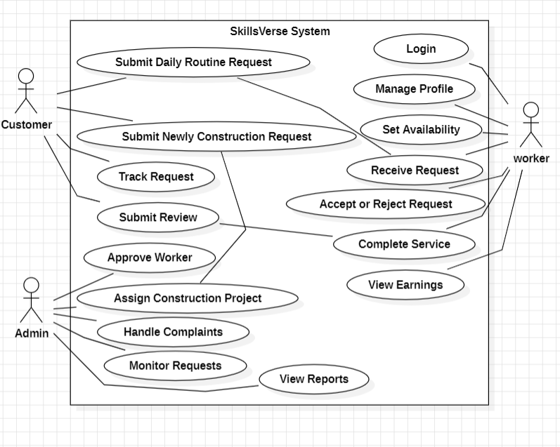

3.4 Classes / Objects
This section describes the main classes of the SkillsVerse system and their relationships. The system follows an object-oriented design approach, where the Customer, Worker, and Admin classes inherit from the base User class. The diagram below represents the structural model of the system.
3.4.1 Class Diagram
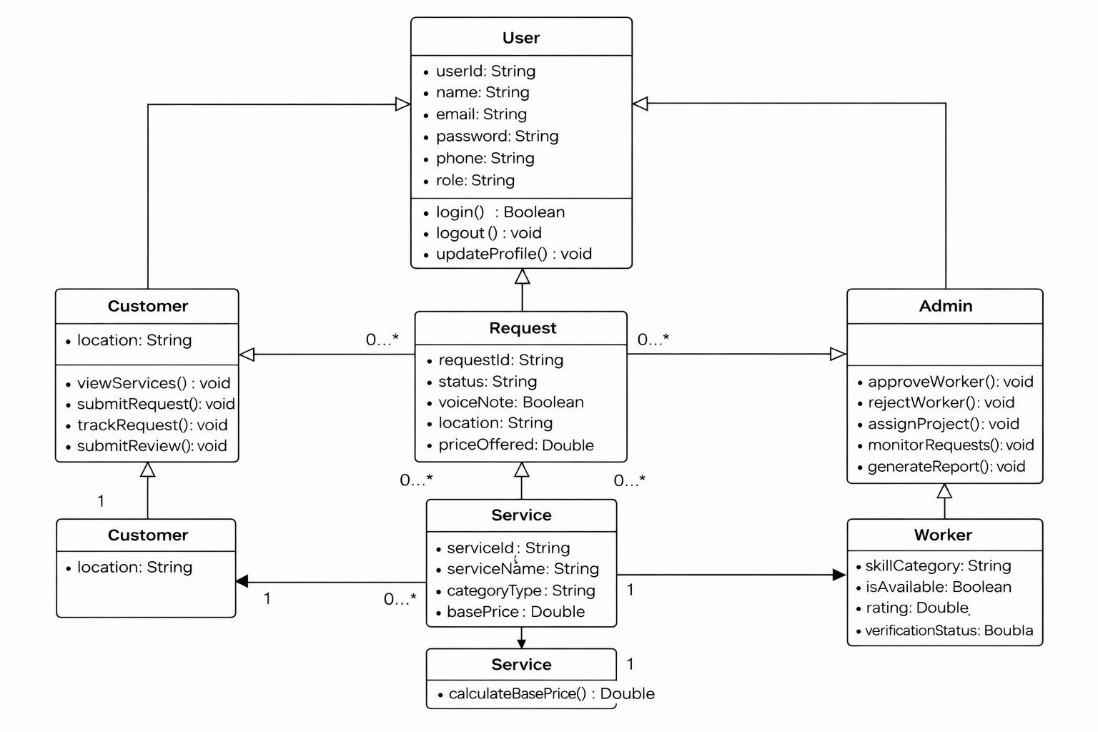

3.5 Non-Functional Requirements
Non-Functional Requirements describe the quality attributes and operational characteristics of the SkillsVerse system. These requirements define how the system performs its functions rather than what functions it performs.

3.5.1 Performance
The SkillsVerse system must provide fast and efficient performance to ensure a smooth user experience.
Requirements:
- The system shall process a customer’s Daily Routine service request within 2–3 seconds.
- The system shall quickly identify and notify the nearest available worker using map-based location services.
- Voice note recording and uploading shall be processed without significant delay.
- The system shall support multiple concurrent users without degradation in performance.

3.5.2 Reliability
The system must operate reliably to ensure that service requests and user data are handled accurately.
Requirements:
- Customer job requests shall be delivered to the nearest available worker without failure.
- The system shall prevent loss of request data in case of temporary network interruptions.
- System failures shall not result in permanent loss of stored data.
- Request status updates shall be accurate and consistent across the platform.

3.5.3 Availability
The SkillsVerse system shall be available to users at all times.
Requirements:
- The system shall maintain 24/7 availability for customers and workers.
- Customers shall be able to submit service requests at any time.
- Workers shall receive job notifications whenever a request is assigned to them.
- Scheduled maintenance shall be performed with minimal system downtime.

3.5.4 Security
The system must ensure the security and privacy of user information.
Requirements:
- The system shall implement secure authentication for user login.
- User passwords shall be stored using encrypted hashing techniques.
- Unauthorized access to system data shall be restricted and prevented.
- Customer and worker location data shall be securely protected.

3.5.5 Maintainability
The system shall be designed to allow easy maintenance and future updates.
Requirements:
- The system code shall be modular and well-documented.
- Developers shall be able to identify and fix bugs efficiently.
- New services, categories, and features shall be added without major modifications to the system.
- System updates shall be implemented with minimal disruption to users.

3.5.6 Portability
The SkillsVerse system shall operate across different platforms and devices.
Requirements:
- The system shall be accessible through modern web browsers on desktop and mobile devices.
- The platform shall support multiple operating systems, including Windows, Android, and iOS.
- The system architecture shall allow future integration with mobile applications.

3.6 Inverse Requirements
Inverse requirements specify what the system will not support or intentionally restrict.
Examples:
- The system will not allow customers to submit Daily Routine service requests using text descriptions; only voice notes will be supported.
- Customers will not be able to submit Newly Construction project requests without logging into the system.
- The system will not assign jobs randomly; service requests will only be sent to the nearest available worker using location-based services.
- Users will not be able to create worker accounts without proper verification and administrative approval.

Appendix B: IV & V Report
(Independent verification & validation)
IV & V Resource

Name Signature

S# | Defect Description | Origin Stage | Status | Fix Time
 |  |  |  | Hours | Minutes
1
2
3
…
Table 1: List of non-trivial defects

This document has been adapted from the following:
- Previous project templates at UCP
- High-level Technical Design, Centers for Medicare & Medicaid Services. (www.cms.gov)

